Basic Commands
Tasks
1.Open your Linux terminal and use the pwd, ls, and cd commands to navigate to your Downloads folder and list all files inside it.

pwd

ls

cd
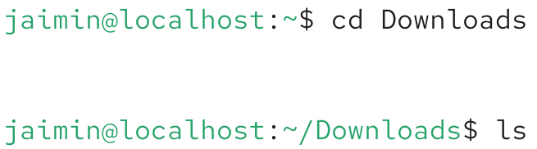

2.Create a new directory called 'music_playlist' inside your home directory using the mkdir command, then use the touch command to create three empty files named song1.mp3, song2.mp3, and song3.mp3 inside it.
mkdir

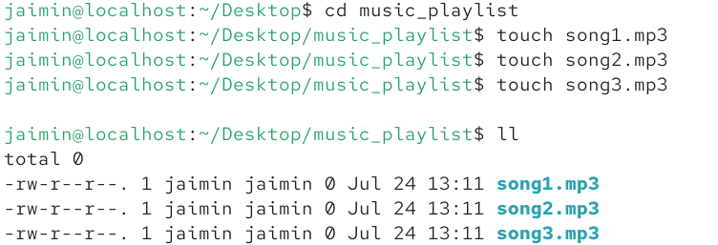
touch

3.Use the cp command to copy all files from your 'music_playlist' directory to a new directory called 'backup_playlist', then use the ls command to verify the files were copied.
cp&ll
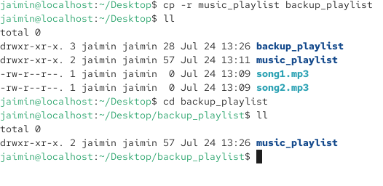
4.Use the mv command to rename 'song1.mp3' to 'favorite_song.mp3' inside the 'music_playlist' directory, and then use the rm command to delete 'song3.mp3' from the same directory. Hint Make sure you are inside the correct directory before running mv or rm.
mv
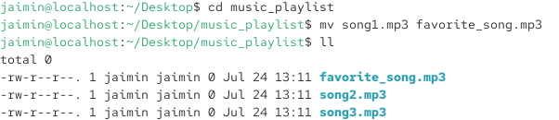

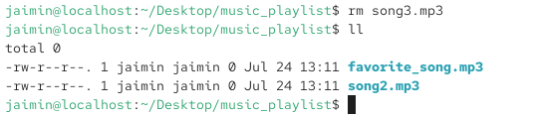
rm

